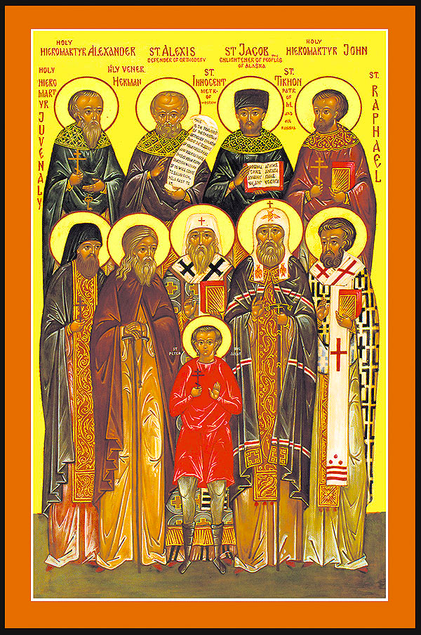 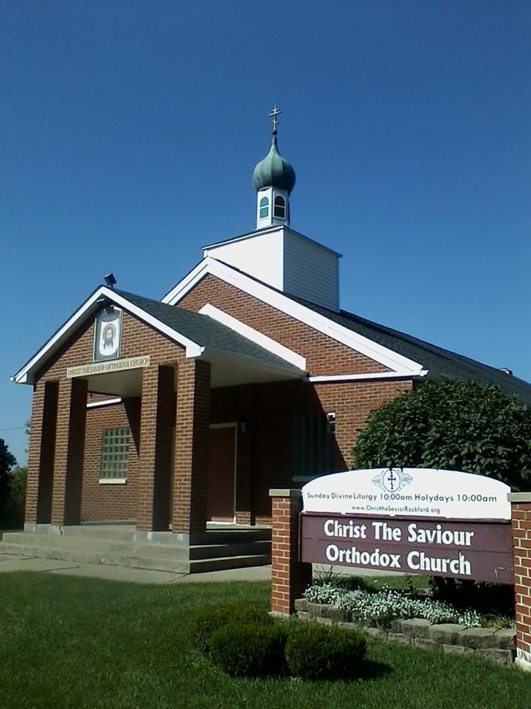

***Today we will have a TYPICA service in Fr. Jonathan’s absence. Fr. Jonathan will be back in Rockford late this evening.***

**THANK YOU! THANK YOU! THANK YOU!**

*To everyone who helped and supported our Konevets Quartet concert. The quartet was very impressed by our turnout and would* ***love*** *to come back to Rockford! We had nearly* ***120 people*** *come to the concert!*

**MONDAY** we will have **Great Vespers for the Nativity of St. John the Baptist** at **5pm.** Our book study on *Fr. Demitri’s Cross* will follow.

**TUESDAY at 10am** we will have a Divine Liturgy for the **Nativity of St. John the Baptist**. Please plan on joining us!

**Summer With the Saints** is **Thursday evening** at **5:30.** We will be studying St. Siloan the Athonite, a Russian saint who lived in the early 1900’s. A peasant with a country upbringing lead a life that was like other Russian boys his age with visiting the local Tavern and drinking vodka until one day he had a new desire and thirst that lead him out of the bar and to the Holy Mountain.

**Women’s Study** with Paniis **FRIDAY** at **5PM**. We will have a **Prosfora Workshop.** Our parish prosfora bakers Debbie and Nancy will help lead the workshop.

No services or classes on June 25th currently scheduled.  
  
Reminder: **BOOK STUDY MONDAY AFTER Great Vespers** at 5PM.

**Vespers is Saturday at 5pm as usual**

**SAVE THE DATE! AUGUST 23 FAMILY BARBEQUE!**

Saturday August 23rd we will have a family barbeque together with the other Orthodox Communities. This is a chance for us and **especially our youth** to have fellowship with our brothers and sisters in Christ. Save the Date and get those burgers ready!

**WE WANT TO SEE ALL OF THE KIDS THERE!  
  
Thank you also for coming today as Pani Marianna and I in Pennsylvania with Fr. Sam for Seminarian Graduate Matthew Dutko’s wedding to Katie Szkapa. He is the grandson of the late Protopresbyter Fr. Stephen Dutko of blessed Memory, a well-loved priest throughout the diocese. May God bless them with many years!  
With love in Christ, Fr. Jonathan :)**

**All Saints of North America**

***Also Commemorated this day:*** *Hieromartyr Eusebius, Bishop of Samosata (380). Martyrs Zeno and his servant, Zenas, of Philadelphia (304). Martyrs Galacteon, Juliana, and Saturninus, of Constantinople. St. Alban, Protomartyr of Britain (ca. 287). Hieromartyr Nicetas of Remesiana (414-420). Martyr Nicetas the Dacian (370-372). St. Grigorie Dascalu, Metropolitan of Wallachia (Romania).*

**Tone 1**

**Todays Readings:**

Romans 2:10-16

Matthew 4:18-23

We are so glad that you have joined us for our worship and sharing in the grace of God in our Lord Jesus Christ!

**Please join us** for coffee and fellowship after the service!

We also ask our visitors to please **sign our Guest Register.** Note that the Holy Gifts of Communion are for Orthodox Christians in good standing.

Please list the loved ones that you would like included in the prayers during the Liturgy on the sheet on the candle desk.

***Christ the Savior   
Orthodox Church***

*1802 Pershing Ave.   
Rockford, IL*

**June 22nd , 2014**

Rev. Fr. Jonathan Bannon

*jsbannon@gmail.com**(860)919-0994*

**Epistle Reading**

**Romans 2:10-16**

[Bretheren], glory, honor, and peace to everyone who works what is good, to the Jew first and also to the Greek. For there is no partiality with God. For as many as have sinned without law will also perish without law, and as many as have sinned in the law will be judged by the law (for not the hearers of the law are just in the sight of God, but the doers of the law will be justified; for when Gentiles, who do not have the law, by nature do the things in the law, these, although not having the law, are a law to themselves, who show the work of the law written in their hearts, their conscience also bearing witness, and between themselves their thoughts accusing or else excusing them) in the day when God will judge the secrets of men by Jesus Christ, according to my gospel.

**Gospel Reading  
Matthew 4:18-23**

And Jesus, walking by the Sea of Galilee, saw two brothers, Simon called Peter, and Andrew his brother, casting a net into the sea; for they were fishermen. Then He said to them, “Follow Me, and I will make you fishers of men.” They immediately left their nets and followed Him. Going on from there, He saw two other brothers, James the son of Zebedee, and John his brother, in the boat with Zebedee their father, mending their nets. He called them, and immediately they left the boat and their father, and followed Him. And Jesus went about all Galilee, teaching in their synagogues, preaching the gospel of the kingdom, and healing all kinds of sickness and all kinds of disease among the people..

An Excerpt from St. John Chrysostom’s Sermon on Today’s Gospel

And walking by the sea of Galilee, He saw two brethren, Simon that was surnamed Peter, and Andrew his brother, casting a net into the sea; for they were fishers. And He saith unto them, Come ye after me, and I will make you fishers of men. And they left their nets, and followed Him.”

[Note] their faith, and their obedience. For though they were in the midst of their work (and ye know how greedy a thing fishing is), when they heard His command, they delayed not, they procrastinated not, they said not, “let us return home, and converse with our kinsfolk,” but “they forsook all and followed,” even as Elisha did to Elijah.” Because such is the obedience which Christ seeks of us, as that we delay not even a moment of time, though something absolutely most needful should vehemently press on us. Wherefore also when some other had come unto Him, and was asking leave to bury his own father, not even this did He permit him to do; to signify that before all we ought to esteem the following of Himself.

But if thou should say, “the promise is very great;” even for this do I most admire them, for that when they had not as yet seen any sign, they believed in so great a reach of promise, and accounted all but second to that attendance. And this, because they believed that by what words they were caught, by the same they would be able to catch others also.

To these, then, such was His promise: but to James and John He saith no such thing. For the obedience of those that had gone before had by this time paved the way for these. And besides they had also heard many things before concerning Him

…

When therefore [Christ] had caught them, then He begins in their presence to work miracles, by His deeds confirming the words of John concerning Him. And He was continually frequenting their synagogues, even by this instructing them that He was not a sort of adversary of God and deceiver, but that He was come in accordance with the Father.

**Our church website along with sermons is at: www.christthesaviorrockford.org**